Now we will talk about how to make list in react native

By list we mean

Suppose you are working on a food application

Then there you might need to create list of dishes and foods

Or if you are working on college management system then you might want to create list of Teacher , courses etc

If you are working on ecommerce then you need to create set of products

What teacher is saying is that when you make a project then there are high chances that you can create list with dynamic data

How to make it teacher will tell us now

In react native we can mainly create list with two ways one by flatlist and by selection list

We will study it in next part

It is not that there will be only two lesson on list there will be plenty because it is very important

Topic and many interview questions are often asked about it

The more idea you will have about creating list , playing with array inside react native or any other application the better your logic will build and you will feel confident in developing any application

In upcoming time we will fetch data from API or from database We will make list on the basis of it

For now we will create them through static arrays

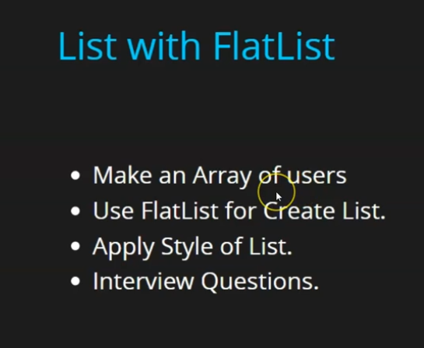

First teacher will tell us how to make an array of user

There will be array which contains the user is and name so that you can use it create list

Then will use flatlist to create list from it and the list will not look god because style is not attached to it

We will apply styles so you will practise styles also

Now we are going to cover Interview Question

In your app.jsx

You can take states but for now we use static and will not update it and now inside this array add an objects representing their students and each student have id and name

Now we import FlatList from react-native

And use it in return of component by using it as an empty element and then pass it prop “data” for telling what data or array you are sending for creating a list always remember “data” always take an array

And then comes renderItem prop

In this prop you tell what each item of the list will contain and how they will be visible whether we represent each item of the list as a button and other elements

Inside this we pass normal JSX and then inside we make an arrow function

We usually pass arrow function in renderitems prop or inside which we tell how our elements will look

3:55

This arrow function will contain a parameter that will represent each element of the array that you passed in the data prop

And we will use it inside the jsx of the arrow function

**Discovery:-**

I think I have discovered that if I don’t use curly bracket after the arrow function and just use single element as parent then it will be returned

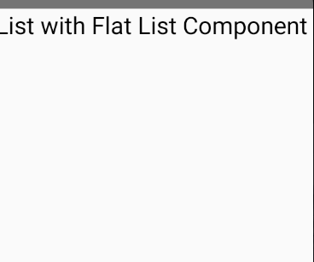

Code:-

function App() {

 const users = [

  {

    id:1,

    name:'Anil'

  },

  {

    id:2,

    name:'Sam'

  },

  {

    id:3,

    name:'Peter'

  },

  {

    id:4,

    name:'Bruce'

  }

 ]

  return (

    <>

    <Text style={{fontSize:31}}>

      List with Flat List Component

    </Text>

    <FlatList data={users} renderItem={(item)=><Text>{item.name}</Text>

    }/>

    </>

  );

}

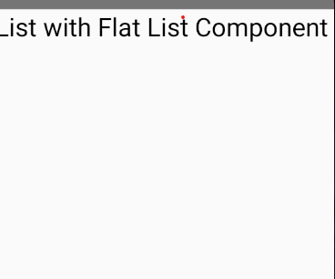

We don’t see any output

Becaue we have done mistake here that renderitem prop take parameter as an object

So

    <FlatList data={users} renderItem={({item})=><Text>{item.name}</Text>

Now we will see the output

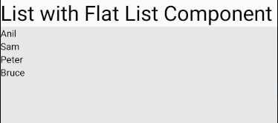

It does not look good so we will apply style on each of the item

By

<FlatList data={users} renderItem={({item})=><Text style={{fontSize:20}}>{item.name}</Text>

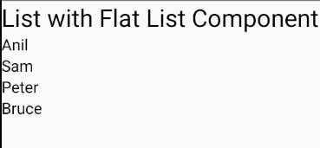

Even now if we increase our array by adding any other element then It will still work s we can work with dynamic list

Suppose we add an object having name attribute tony and id 10 in the users array

Then now the UI will look like this

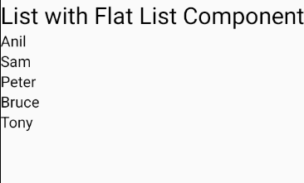

Now what is the work of this id

Suppose you want to give unique id to every item so that we can identify that this item is unique

What is the use of it will be told by the teacher later

5:40

There is another prop that is Key extractor its use will be discussed when we will scroll tehn you will understand it better

<FlatList data={users} renderItem={({item})=><Text style={{fontSize:20}}>{item.name}</Text>}

    keyExtractor = {item=>item.id}

here we pass the callback similarly we do with render item but here we just return item.id

her it is just a unique id which we can tell

even in normal cases we want to make basic list we don’t need it but you will not see the difference here but when you will use scroll then its actual us will be there but for now we want that stylw should be good it is not looking good

so we make a const style and do internal css here like we did before Now code look like below

  return (

    <>

    <Text style={{fontSize:31}}>

      List with Flat List Component

    </Text>

    <FlatList data={users} renderItem={({item})=><Text style={styles.item}>{item.name}</Text>}

    keyExtractor = {item=>item.id}

    />

    </>

  );

}

const styles = StyleSheet.create({

  item: {fontSize: 24, padding: 10},

});

And output will be like below

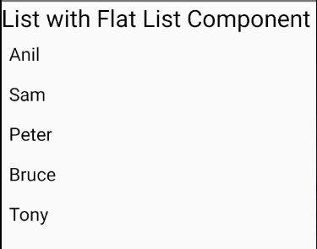

Now in style we add other properties like backGroundColor , color and borderColor ,borderWidth and margin

const styles = StyleSheet.create({

  item: {fontSize: 24,

      padding: 10,

      backgroundColor:'#0000ff',

      margin:10,color:'#ffffff',

      borderWidth:1,

      borderColor:'black'

    },

});

The output will be

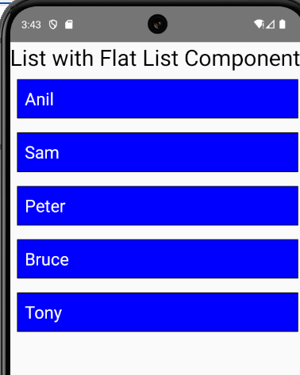

Now it is looking good and it looks like a list now

So for now a simple list is formed

In next part the teacher will tell us about selection list and later but in next part teacher will tell us selection list and then we will take button and textbox as we add item through button they will be added to the list

For now we have made top to down list we will make left to right horizontal

Suppose one row get filled then next will come below it like a grid

As the teacher tell us many videos are going to come

What interview question could be asked

First will be how you will make a list we will answer it by Flatlist

Second they can ask whatever data you use inside the flatlist what will be its type

It can be a normal array or it can be array of object as we have used it here

But if there are normal array with normal values

It will be like list

Then from there you can print a list So it take both

In next lesson we will discuss about selection list